🎂 FRESH BAKES
Online Bakery Web Application
PROJECT REPORT
Submitted in partial fulfilment of the requirements for
Bachelor of Computer Applications (BCA) — 2nd Semester
Subject: Web Stack Development
Academic Year: 2025 – 2026

Table of Contents
- i. Introduction
- ii. Aim and Objectives
- iii. Future Scope
- iv. Hardware & Software Requirements
- v. Data Flow Diagram (DFD)
- vi. Database Design
- vii. Screenshots
- viii. Source Code

i. Introduction
Fresh Bakes is a fully functional, front-end web application developed as part of the Web Stack Development project for the 2nd Semester, BCA programme. The application simulates a real-world online bakery store where customers can explore a curated menu of baked goods, add items to a shopping cart, and complete a purchase through a structured checkout process.

The bakery, named Fresh Bakes, is modelled after a neighbourhood bakery based in Ghaziabad, Uttar Pradesh. Founded in 2015 by Nyati, Fresh Bakes is known for handcrafting cakes, cupcakes, cookies, pastries, and bread using only natural ingredients, baked fresh every single day without the use of preservatives.

The website is entirely built using HTML5, CSS3, and Vanilla JavaScript — without any external JavaScript framework. Key technologies and features include:
- Responsive multi-page navigation (Home, Products, About, Contact, Cart, Checkout, Order Success)
- Dynamic product catalogue with category-filter buttons
- Shopping cart powered by localStorage for persistent state
- Live cart badge counter visible across all pages
- Full checkout form with order summary and payment method selection
- Order confirmation / success page with detailed order recap
- AI-powered chatbot assistant (Baky) for customer queries
- Toast notifications for user feedback
- Fully responsive layout with hamburger menu for mobile screens

The project demonstrates the practical application of front-end web development skills covering semantic HTML, advanced CSS (custom properties, flexbox, grid, animations), DOM manipulation, and client-side data persistence.

ii. Aim and Objectives
Aim:
To design and develop a fully functional, visually appealing, multi-page online bakery web application that provides an end-to-end shopping experience — from product browsing to order placement — using only core web technologies (HTML, CSS, JavaScript).

Objectives:
- To create an attractive, brand-consistent Home Page showcasing the bakery's identity and bestselling products.
- To implement a dynamic Products Page with all menu items organised by categories (Cakes, Cupcakes, Cookies, Pastries, Bread) and filterable by category.
- To build a fully functional Shopping Cart using localStorage that persists across page navigation.
- To develop a multi-field Checkout Page with delivery details form and payment method selection (Cash, UPI, Card).
- To display an Order Success Page with a complete order summary after successful order placement.
- To create an About Us Page showcasing the bakery's story, statistics, team members, and values.
- To build a Contact Us Page with a contact form, business hours table, and location information.
- To integrate an AI-rule-based chatbot (Baky) that answers common customer queries.
- To ensure the website is responsive and works correctly on both desktop and mobile screen sizes.
- To demonstrate proper usage of HTML5 semantic elements, CSS custom variables, flexbox/grid layouts, and JavaScript DOM manipulation.

iii. Future Scope
The current version of Fresh Bakes is a front-end prototype. The following enhancements are planned for future iterations of the project:

Backend & Database Integration (To be added in future presentation):
- Integration with a backend server (Node.js / PHP / Django) and a relational database (MySQL / MongoDB) to store user accounts, order history, and product inventory persistently.
- User authentication system — Login, Register, and Forgot Password functionality.
- Admin panel/dashboard for the bakery owner to manage products, view orders, and track revenue.

Payment Gateway (To be added in future presentation):
- Integration of real payment gateways like Razorpay, PayU, or PayPal for actual online transactions.
- UPI deep link integration for direct payment in mobile browsers.

Enhanced Features (To be added in future presentation):
- Product review and rating system for each item.
- Wishlist / Favourites functionality.
- Real-time order tracking with estimated delivery time.
- WhatsApp API integration for automated order confirmations and updates.
- Email confirmation to customers upon placing orders.
- Loyalty points / coupon code system.

Technical Enhancements:
- Progressive Web App (PWA) support for offline access and mobile home screen installation.
- Search functionality across all products.
- Internationalisation (i18n) support for multiple languages.
- Accessibility (a11y) improvements to meet WCAG 2.1 standards.

iv. Hardware & Software Requirements
Hardware Requirements
Component | Minimum Requirement | Recommended
Processor | Intel Core i3 / AMD Ryzen 3 | Intel Core i5 or higher
RAM | 4 GB | 8 GB or more
Storage | 256 GB HDD | 512 GB SSD
Display | 1024 × 768 resolution | 1920 × 1080 Full HD
Internet | Broadband 2 Mbps | Broadband 10 Mbps or higher

Software Requirements — Development
Software | Purpose | Version Used
Visual Studio Code | Source code editor / IDE | Latest
Google Chrome / Edge | Browser for development & testing | Latest
Node.js | JavaScript runtime (report generation) | v24.13.0
Git | Version control (optional) | Latest

Software Requirements — End User
Software | Purpose
Any modern web browser | Google Chrome, Firefox, Safari, Edge
Internet connection | Required to load Google Fonts
No installation needed | Pure HTML/CSS/JS — open directly in browser

Technologies Used
Technology | Role
HTML5 | Page structure and semantic markup
CSS3 | Styling, animations, responsive layout
Vanilla JavaScript (ES6+) | Interactivity, cart logic, chatbot, DOM manipulation
localStorage API | Client-side persistent cart and order storage
Google Fonts API | Playfair Display & Lato typefaces

v. Data Flow Diagram (DFD)
Level 0 — Context Diagram
The highest-level view shows the Fresh Bakes system and its interaction with the key external entity — the Customer.

[ CUSTOMER ] ──── Browse / Order / Query ────► [ FRESH BAKES SYSTEM ]
[ FRESH BAKES SYSTEM ] ──── Products / Confirmation / Responses ────► [ CUSTOMER ]

Level 1 — Main Processes
Process No. | Process Name | Input | Output | Data Store
1.0 | Browse Products | Category selection | Filtered product list | Product Catalogue (JS Array)
2.0 | Manage Cart | Add / Remove / Change Qty | Updated cart, badge count | localStorage (freshBakesCart)
3.0 | Checkout | Delivery details, Payment choice | Order object created | Form inputs
4.0 | Place Order | Order object, Cart data | Order saved, Cart cleared | localStorage (freshBakesOrder)
5.0 | Display Success | Order ID from localStorage | Order confirmation screen | localStorage (freshBakesOrder)
6.0 | Chatbot Query | User message text | Rule-matched bot reply | Rules array (in-memory)
7.0 | Contact Form | Name, Email, Message | Toast confirmation message | None (front-end only)

Level 2 — Cart Sub-process Detail
Step | Action | Result
2.1 | User clicks 'Add to Cart' | Item pushed to cart array in localStorage
2.2 | Item already exists in cart | Quantity incremented by 1
2.3 | User clicks '+' or '−' | Quantity updated / item removed if qty < 1
2.4 | Cart page loads | Cart read from localStorage, rendered to DOM
2.5 | Subtotal ≥ ₹599 | Delivery charge set to FREE (₹0)
2.6 | Subtotal < ₹599 | Delivery charge set to ₹49

Page Navigation Flow
Home ──► Products ──► [Add to Cart] ──► Cart ──► Checkout ──► Order Success
│ │
▼ ▼
About / Contact Back to Home

vi. Database Design
Fresh Bakes is a front-end only application in its current version. It uses the browser's localStorage API for client-side data persistence. There is no server-side or relational database in the current implementation. The following section documents the data structures currently used, and the proposed database schema for the future backend version.

A. Current: localStorage Data Structures
1. Cart — Key: freshBakesCart
Field | Type | Description
id | String | Unique product ID (e.g. 'c1', 'u2')
name | String | Product name (e.g. 'Red Velvet Cake')
price | Number | Price per unit in INR (e.g. 799)
emoji | String | Emoji icon representing the product
qty | Number | Quantity added to cart

2. Order — Key: freshBakesOrder
Field | Type | Description
id | String | Order ID generated as 'FB' + Date.now()
customer | String | Full name (First + Last) of customer
phone | String | Customer's phone number
address | String | Delivery address textarea input
city | String | City of delivery
payment | String | Payment method: 'cod' | 'upi' | 'card'
items | Array | Cart items array at time of order
total | Number | Final order total including delivery
date | String | Localised timestamp of order placement

B. Proposed: Relational Database Schema (Future)
(To be implemented in a future version with a backend — will be presented in subsequent presentations.)

Table: Users
Column | Type | Constraint
user_id | INT | PRIMARY KEY, AUTO_INCREMENT
name | VARCHAR(100) | NOT NULL
email | VARCHAR(100) | UNIQUE, NOT NULL
password_hash | VARCHAR(255) | NOT NULL
phone | VARCHAR(15)
created_at | DATETIME | DEFAULT NOW()

Table: Products
Column | Type | Constraint
product_id | VARCHAR(10) | PRIMARY KEY
name | VARCHAR(150) | NOT NULL
category | VARCHAR(50) | NOT NULL
price | DECIMAL(8,2) | NOT NULL
description | TEXT
badge | VARCHAR(50) | NULLABLE
in_stock | BOOLEAN | DEFAULT TRUE

Table: Orders
Column | Type | Constraint
order_id | VARCHAR(30) | PRIMARY KEY
user_id | INT | FOREIGN KEY → Users
total_amount | DECIMAL(10,2) | NOT NULL
delivery_charge | DECIMAL(6,2) | DEFAULT 0
payment_method | ENUM('cod','upi','card') | NOT NULL
delivery_address | TEXT | NOT NULL
status | ENUM('pending','confirmed','delivered') | DEFAULT 'pending'
ordered_at | DATETIME | DEFAULT NOW()

Table: Order_Items
Column | Type | Constraint
item_id | INT | PRIMARY KEY, AUTO_INCREMENT
order_id | VARCHAR(30) | FOREIGN KEY → Orders
product_id | VARCHAR(10) | FOREIGN KEY → Products
quantity | INT | NOT NULL
unit_price | DECIMAL(8,2) | NOT NULL

vii. Screenshots
The following screenshots show the Fresh Bakes website running in a web browser.

1. Home Page (index.html)
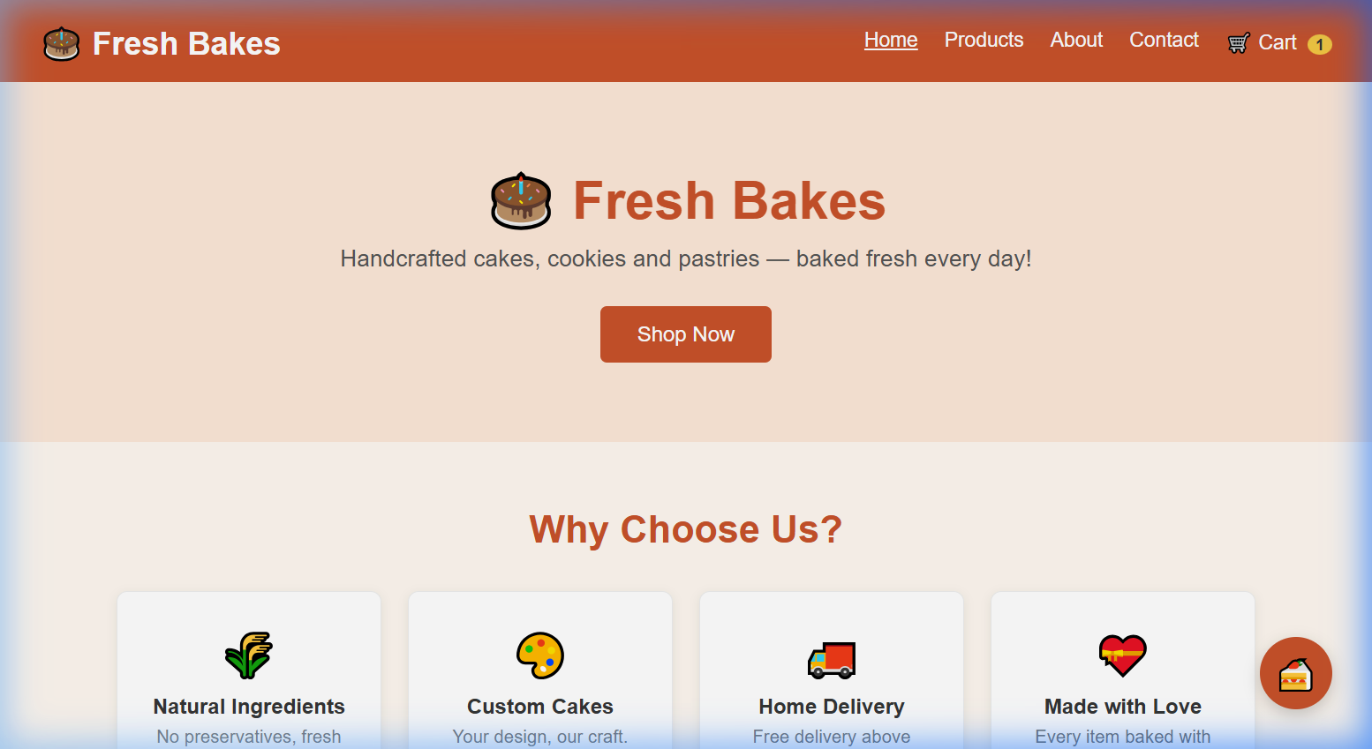
The Home Page features a hero banner, 'Why Choose Us' feature cards, and bestseller products with an Add to Cart function.

2. Products Page (product.html)
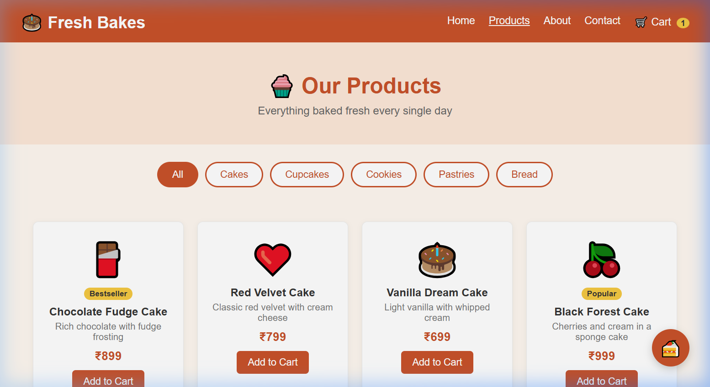
The Products Page lists all 14 menu items with category filter buttons (All, Cakes, Cupcakes, Cookies, Pastries, Bread).

3. About Us Page (about.html)
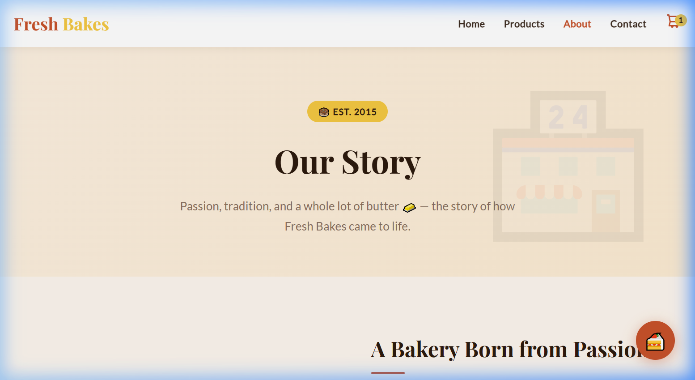
The About Page includes the bakery's story, animated statistics (10+ years, 500+ customers, 50+ products), meet-the-team cards, and our values.

4. Contact Us Page (contact.html)
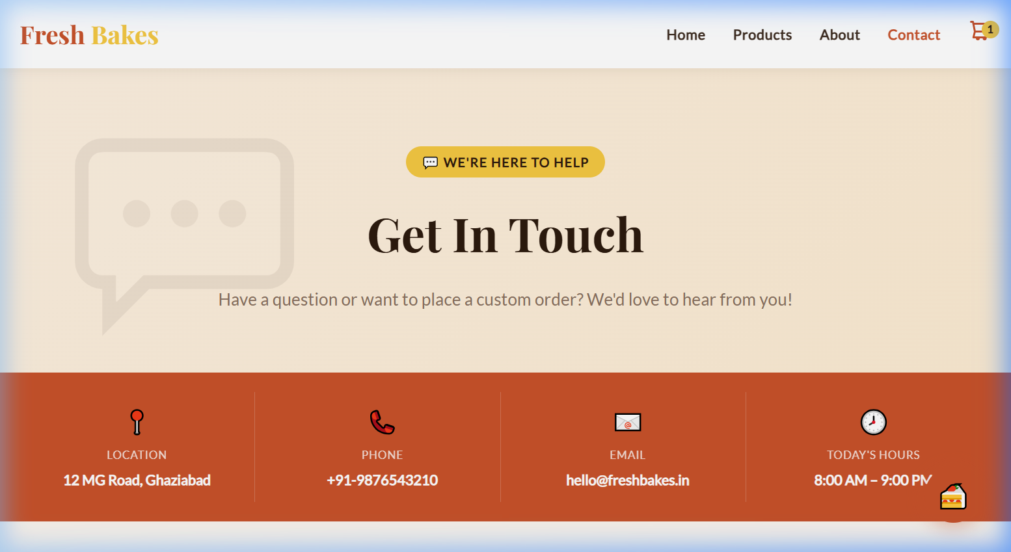
Contact Page with info cards (address, phone, email, WhatsApp), bakery hours table, and a contact form with subject chip selectors.

5. Cart Page (cart.html)
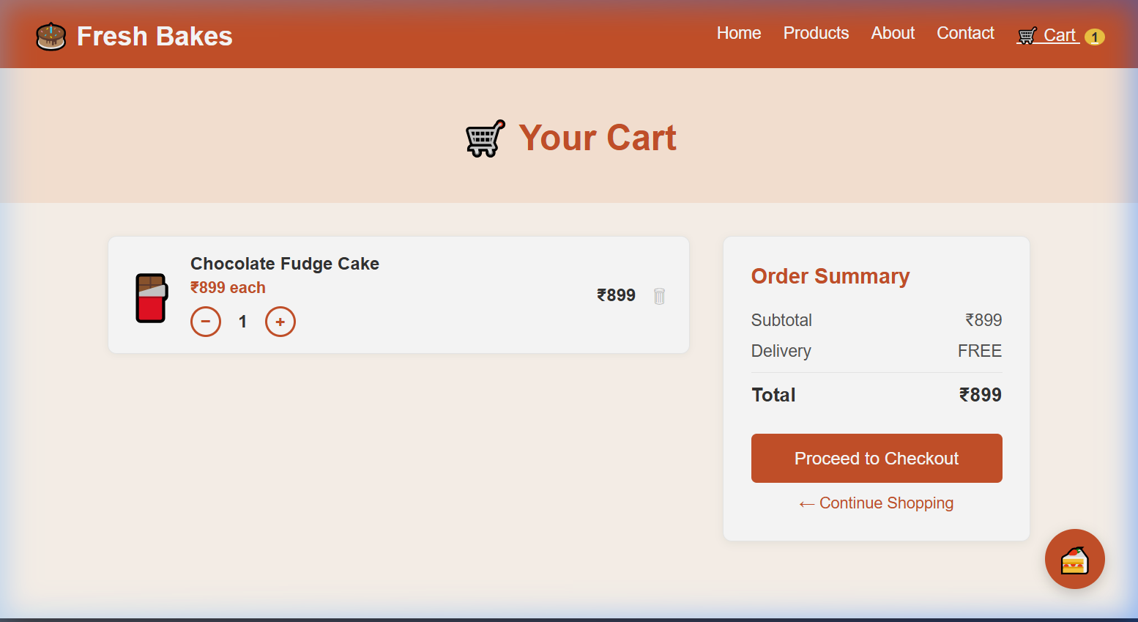
Cart Page shows items with quantity controls (+ / −), item totals, order summary with free delivery above ₹599, and Proceed to Checkout button.

6. Checkout Page (checkout.html)
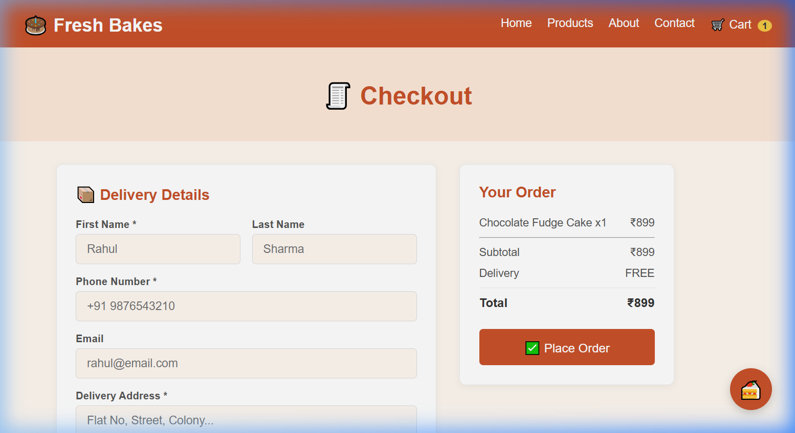
Checkout Page with Delivery Details form and Payment Method selection (Cash / UPI / Card) alongside the live order summary.

7. Order Success Page (success.html)
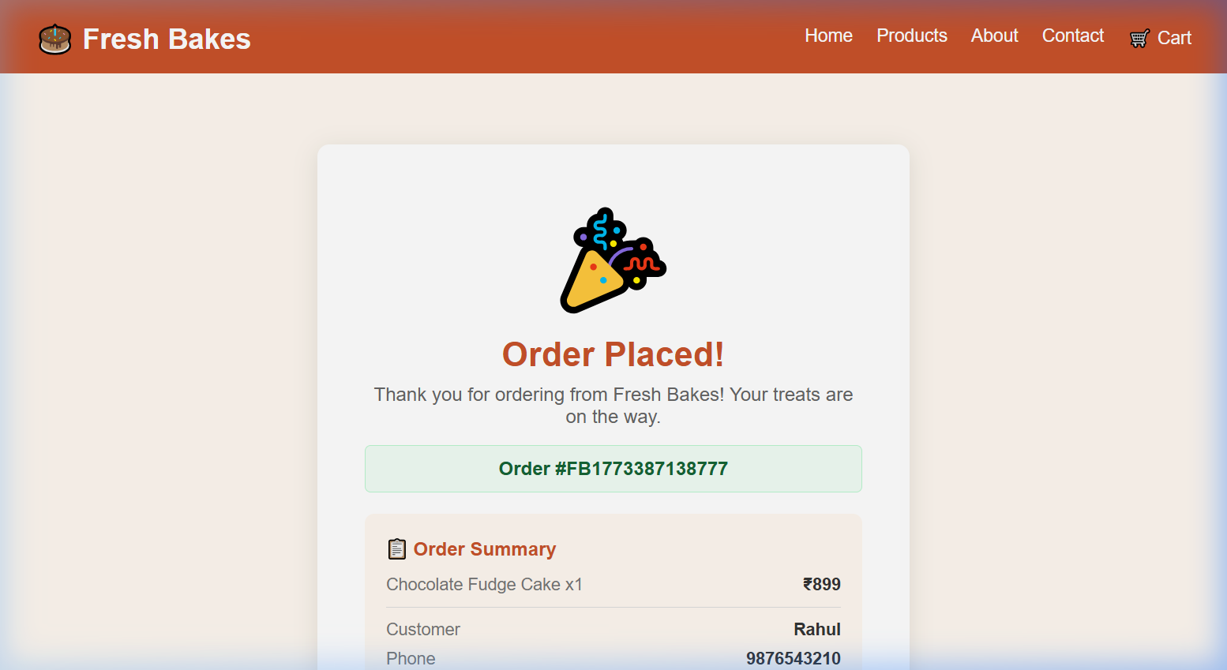
Order Success Page confirms the order with a unique Order ID, full order summary, customer details, and estimated delivery time.

viii. Source Code
Below is the complete source code for all HTML files of the Fresh Bakes web application.
CSS and JavaScript are embedded within their respective HTML files using <style> and <script> tags.

Home Page — index.html
<!DOCTYPE html>
<html lang="en">
<head>
<meta charset="UTF-8"/>
<meta name="viewport" content="width=device-width, initial-scale=1.0"/>
<title>Fresh Bakes - Home</title>
<link rel="stylesheet" href="style.css"/>
</head>
<body>

<!-- NAVBAR -->
<nav>
<a class="logo" href="index.html">🎂 Fresh Bakes</a>
<ul>
<li><a href="index.html">Home</a></li>
<li><a href="product.html">Products</a></li>
<li><a href="about.html">About</a></li>
<li><a href="contact.html">Contact</a></li>
<li><a href="cart.html" class="cart-link">🛒 Cart <span class="cart-badge" id="cartCount">0</span></a></li>
</ul>
</nav>

<!-- HERO -->
<section class="hero">
<h1>🎂 Fresh Bakes</h1>
<p>Handcrafted cakes, cookies and pastries — baked fresh every day!</p>
<a href="product.html" class="btn">Shop Now</a>
</section>

<section class="section">
<h2>Why Choose Us?</h2>
<div class="cards">
<div class="card"><div class="icon">🌾</div><h3>Natural Ingredients</h3><p>No preservatives, fresh every day.</p></div>
<div class="card"><div class="icon">🎨</div><h3>Custom Cakes</h3><p>Your design, our craft.</p></div>
<div class="card"><div class="icon">🚚</div><h3>Home Delivery</h3><p>Free delivery above ₹599.</p></div>
<div class="card"><div class="icon">💝</div><h3>Made with Love</h3><p>Every item baked with care.</p></div>
</div>
</section>

<!-- BESTSELLING -->
<section class="products">
<h2>Our Bestsellers</h2>
<div class="product-grid" id="homeProducts"></div>
<br><br>
<a href="product.html" class="btn">View All Products</a>
</section>

<!-- FOOTER -->
<footer>
<p>© 2025 Fresh Bakes | 12 MG Road, Ghaziabad | +91-9876543210</p>
<p>Mon-Sat: 8am-9pm | Sun: 9am-7pm</p>
</footer>

<!-- TOAST -->
<div class="toast" id="toast"></div>

<!-- CHATBOT -->
<script src="chatbot.js"></script>

<script>
/* ======= CART ======= */
function getCart() { return JSON.parse(localStorage.getItem("freshBakesCart")) || []; }
function saveCart(cart) { localStorage.setItem("freshBakesCart", JSON.stringify(cart)); updateBadge(); }
function updateBadge() {
const count = getCart().reduce((s, i) => s + i.qty, 0);
const el = document.getElementById("cartCount");
if (el) el.textContent = count;
}
function addToCart(item) {
const cart = getCart();
const found = cart.find(c => c.id === item.id);
if (found) found.qty += 1;
else cart.push({ ...item, qty: 1 });
saveCart(cart);
showToast(item.name + " added to cart! 🎂");
}
function showToast(msg) {
const t = document.getElementById("toast");
t.textContent = msg;
t.classList.add("show");
setTimeout(() => t.classList.remove("show"), 2500);
}
updateBadge();

/* ======= BESTSELLER PRODUCTS ======= */
const featured = [
{ id:"p1", name:"Chocolate Fudge Cake", price:899, emoji:"🍫", desc:"Rich chocolate with fudge frosting" },
{ id:"p2", name:"Red Velvet Cake", price:799, emoji:"❤️", desc:"Classic red velvet with cream cheese" },
{ id:"p3", name:"Butter Cookies Box", price:299, emoji:"🍪", desc:"12 handcrafted butter cookies" },
{ id:"p4", name:"Assorted Cupcakes", price:349, emoji:"🧁", desc:"6 cupcakes in mixed flavours" },
];
const grid = document.getElementById("homeProducts");
featured.forEach(p => {
grid.innerHTML += `
<div class="product-card">
<div class="emoji">${p.emoji}</div>
<h3>${p.name}</h3>
<p>${p.desc}</p>
<div class="price">₹${p.price}</div>
<button onclick='addToCart(${JSON.stringify(p)})'>Add to Cart</button>
</div>`;
});
</script>

</body>
</html>

Products Page — product.html
<!DOCTYPE html>
<html lang="en">
<head>
<meta charset="UTF-8"/>
<meta name="viewport" content="width=device-width, initial-scale=1.0"/>
<title>Fresh Bakes - Products</title>
<link rel="stylesheet" href="style.css"/>
</head>
<body>

<!-- NAVBAR -->
<nav>
<a class="logo" href="index.html">🎂 Fresh Bakes</a>
<ul>
<li><a href="index.html">Home</a></li>
<li><a href="product.html">Products</a></li>
<li><a href="about.html">About</a></li>
<li><a href="contact.html">Contact</a></li>
<li><a href="cart.html">🛒 Cart <span class="cart-badge" id="cartCount">0</span></a></li>
</ul>
</nav>

<!-- PAGE HEADER -->
<div class="page-top">
<h1>🧁 Our Products</h1>
<p>Everything baked fresh every single day</p>
</div>

<!-- FILTER BUTTONS -->
<div class="filter-bar" id="filterBar"></div>

<!-- PRODUCT GRID -->
<div class="section">
<div class="product-grid" id="productGrid"></div>
</div>

<!-- FOOTER -->
<footer>
<p>© 2025 Fresh Bakes | 12 MG Road, Ghaziabad | +91-9876543210</p>
</footer>

<!-- TOAST -->
<div class="toast" id="toast"></div>

<!-- CHATBOT -->
<script src="chatbot.js"></script>

<script>
/* ======= CART ======= */
function getCart() { return JSON.parse(localStorage.getItem("freshBakesCart")) || []; }
function saveCart(c) { localStorage.setItem("freshBakesCart", JSON.stringify(c)); updateBadge(); }
function updateBadge() {
const el = document.getElementById("cartCount");
if (el) el.textContent = getCart().reduce((s,i) => s+i.qty, 0);
}
function addToCart(item) {
const cart = getCart();
const found = cart.find(c => c.id === item.id);
if (found) found.qty += 1; else cart.push({...item, qty:1});
saveCart(cart);
showToast(item.name + " added to cart! 🎂");
}
function showToast(msg) {
const t = document.getElementById("toast");
t.textContent = msg; t.classList.add("show");
setTimeout(() => t.classList.remove("show"), 2500);
}
updateBadge();

/* ======= PRODUCTS DATA ======= */
const allProducts = [
{ id:"c1", name:"Chocolate Fudge Cake", price:899, category:"Cakes", emoji:"🍫", desc:"Rich chocolate with fudge frosting", badge:"Bestseller" },
{ id:"c2", name:"Red Velvet Cake", price:799, category:"Cakes", emoji:"❤️", desc:"Classic red velvet with cream cheese" },
{ id:"c3", name:"Vanilla Dream Cake", price:699, category:"Cakes", emoji:"🎂", desc:"Light vanilla with whipped cream" },
{ id:"c4", name:"Black Forest Cake", price:999, category:"Cakes", emoji:"🍒", desc:"Cherries and cream in a sponge cake", badge:"Popular" },
{ id:"c5", name:"Pineapple Cake", price:749, category:"Cakes", emoji:"🍍", desc:"Fluffy pineapple sponge cake" },
{ id:"u1", name:"Chocolate Cupcakes", price:49, category:"Cupcakes", emoji:"🧁", desc:"Mini chocolate cupcakes (per piece)" },
{ id:"u2", name:"Vanilla Cupcakes", price:45, category:"Cupcakes", emoji:"🧁", desc:"Vanilla with buttercream (per piece)" },
{ id:"u3", name:"Red Velvet Cupcakes", price:55, category:"Cupcakes", emoji:"🧁", desc:"Red velvet per piece", badge:"New" },
{ id:"k1", name:"Butter Cookies Box", price:299, category:"Cookies", emoji:"🍪", desc:"12 handcrafted butter cookies" },
{ id:"k2", name:"Choco Chip Cookies", price:249, category:"Cookies", emoji:"🍪", desc:"10 cookies with chocolate chips" },
{ id:"pa1", name:"Croissant", price:79, category:"Pastries", emoji:"🥐", desc:"Flaky buttery croissant" },
{ id:"pa2", name:"Éclair", price:89, category:"Pastries", emoji:"🍫", desc:"Choux pastry with cream and chocolate" },
{ id:"b1", name:"Multigrain Loaf", price:89, category:"Bread", emoji:"🍞", desc:"Freshly baked multigrain bread" },
{ id:"b2", name:"Garlic Bread", price:99, category:"Bread", emoji:"🥖", desc:"Crusty garlic bread" },
];

/* ======= FILTER BUTTONS ======= */
const categories = ["All", ...new Set(allProducts.map(p => p.category))];
let active = "All";
const filterBar = document.getElementById("filterBar");

categories.forEach(cat => {
const btn = document.createElement("button");
btn.className = "filter-btn" + (cat === "All" ? " active" : "");
btn.textContent = cat;
btn.onclick = () => {
document.querySelectorAll(".filter-btn").forEach(b => b.classList.remove("active"));
btn.classList.add("active");
active = cat;
renderProducts();
};
filterBar.appendChild(btn);
});

/* ======= RENDER PRODUCTS ======= */
function renderProducts() {
const list = active === "All" ? allProducts : allProducts.filter(p => p.category === active);
const grid = document.getElementById("productGrid");
grid.innerHTML = list.map(p => `
<div class="product-card">
<div class="emoji">${p.emoji}</div>
${p.badge ? `<div class="badge">${p.badge}</div>` : ""}
<h3>${p.name}</h3>
<p>${p.desc}</p>
<div class="price">₹${p.price}</div>
<button onclick='addToCart(${JSON.stringify({id:p.id,name:p.name,price:p.price,emoji:p.emoji})})'>Add to Cart</button>
</div>`).join("");
}
renderProducts();
</script>

</body>
</html>

About Page — about.html
<!DOCTYPE html>
<html lang="en">
<head>
<meta charset="UTF-8"/>
<meta name="viewport" content="width=device-width, initial-scale=1.0"/>
<title>Fresh Bakes — About Us</title>
<link rel="stylesheet" href="style.css"/>
</head>
<body>

<!-- ============ NAVBAR ============ -->
<nav class="navbar">
<div class="container">
<a class="logo" href="index.html">Fresh <span>Bakes</span></a>
<ul class="nav-links">
<li><a href="index.html">Home</a></li>
<li><a href="product.html">Products</a></li>
<li><a href="about.html" class="active">About</a></li>
<li><a href="contact.html">Contact</a></li>
<li>
<a href="cart.html" class="cart-icon">
<svg xmlns="http://www.w3.org/2000/svg" fill="none" viewBox="0 0 24 24" stroke-width="2" stroke="currentColor">
<path stroke-linecap="round" stroke-linejoin="round" d="M3 3h2l.4 2M7 13h10l4-8H5.4M7 13l-1.5 6h13M7 13L5.4 5M10 21a1 1 0 100-2 1 1 0 000 2zm7 0a1 1 0 100-2 1 1 0 000 2z"/>
</svg>
<span class="cart-count" id="cartCount">0</span>
</a>
</li>
</ul>
<div class="hamburger" id="hamburger">
<span></span><span></span><span></span>
</div>
</div>
</nav>

<!-- ============ PAGE HERO ============ -->
<div class="page-hero">
<div class="container">
<div class="page-hero-tag">🎂 Est. 2015</div>
<h1>Our Story</h1>
<p>Passion, tradition, and a whole lot of butter 🧈 — the story of how Fresh Bakes came to life.</p>
</div>
</div>

<!-- ============ ABOUT STORY ============ -->
<section class="about-section">
<div class="container">
<div class="about-grid">

<!-- Image Box -->
<div class="about-img-box">🏪</div>

<!-- Text -->
<div class="about-text">
<h2>A Bakery Born from Passion</h2>
<div class="accent-line"></div>
<p>
Fresh Bakes was founded in 2015 by <strong>Nyati</strong> — a passionate home baker
who turned a love for baking into a full-fledged neighbourhood bakery. What began
as weekend experiments in a small kitchen in Ghaziabad quickly became the talk of
the town.
</p>
<p>
Nyati's philosophy has always been simple — use only the freshest natural ingredients,
bake everything from scratch every single day, and put love into every single product
that leaves the kitchen. No shortcuts. No compromises.
</p>
<p>
Today, Fresh Bakes serves hundreds of happy customers every week — from custom
birthday cakes to freshly baked sourdough — and has grown into a trusted name
for celebrations and everyday indulgences alike.
</p>
<br/>
<a href="product.html" class="btn btn-primary">Explore Our Menu 🎂</a>
</div>

</div>
</div>
</section>

<!-- ============ STATISTICS ============ -->
<section class="stats-section">
<div class="container">
<div class="stats-grid">
<div class="stat-item">
<span class="stat-num">10+</span>
<span class="stat-lbl">Years in Business</span>
</div>
<div class="stat-item">
<span class="stat-num">500+</span>
<span class="stat-lbl">Happy Customers / Month</span>
</div>
<div class="stat-item">
<span class="stat-num">50+</span>
<span class="stat-lbl">Products on Menu</span>
</div>
</div>
</div>
</section>

<!-- ============ TEAM ============ -->
<section class="team-section">
<div class="container text-center">
<h2 class="section-title">Meet Our Team</h2>
<p class="section-sub">The talented people behind every bake 👨‍🍳</p>
<div class="team-grid">

<div class="team-card">
<div class="team-avatar">👩‍🍳</div>
<h3>Nyati</h3>
<div class="role">Founder & Head Baker</div>
<p>The heart of Fresh Bakes. Nyati started it all with a passion for baking and a dream to bring joy through food.</p>
</div>

<div class="team-card">
<div class="team-avatar">👩‍🍳</div>
<h3>Srishty</h3>
<div class="role">Pastry Chef</div>
<p>Srishty crafts our flaky croissants, éclairs, and pastries with precision and a touch of French-inspired magic.</p>
</div>

<div class="team-card">
<div class="team-avatar">👩‍🎨</div>
<h3>Khushi Arora</h3>
<div class="role">Cake Designer</div>
<p>Khushi transforms cakes into edible art. Every custom cake design is her canvas, and she never disappoints.</p>
</div>

<div class="team-card">
<div class="team-avatar">👨‍💼</div>
<h3>Devansh</h3>
<div class="role">Operations Manager</div>
<p>Devansh keeps everything running smoothly — from deliveries to daily operations — so every order arrives perfectly.</p>
</div>

</div>
</div>
</section>

<!-- ============ VALUES ============ -->
<section class="values-section">
<div class="container text-center">
<h2 class="section-title">Our Values</h2>
<p class="section-sub">What we believe in, every single day</p>
<div class="values-grid">
<div class="value-card">
<div class="value-icon">🌾</div>
<h3>Natural Ingredients</h3>
<p>No preservatives, no artificial colours. Just pure, real ingredients sourced fresh locally every morning.</p>
</div>
<div class="value-card">
<div class="value-icon">♻️</div>
<h3>Sustainable Baking</h3>
<p>We use eco-friendly packaging and take care to minimise waste in all our daily baking operations.</p>
</div>
<div class="value-card">
<div class="value-icon">❤️</div>
<h3>Community First</h3>
<p>We support local farmers and donate unsold baked goods to nearby NGOs every evening — giving back always.</p>
</div>
<div class="value-card">
<div class="value-icon">🎓</div>
<h3>Quality Assured</h3>
<p>Every product is carefully checked before it reaches you. Your satisfaction is our biggest reward.</p>
</div>
</div>
</div>
</section>

<!-- ============ FOOTER ============ -->
<footer>
<div class="container">
<div class="footer-grid">
<div class="footer-brand">
<span class="footer-brand-logo">Fresh <span>Bakes</span></span>
<p>Handcrafted with love since 2015.<br>Every bite tells a story of passion and tradition.</p>
</div>
<div class="footer-col">
<h4>Quick Links</h4>
<ul>
<li><a href="index.html">Home</a></li>
<li><a href="product.html">Products</a></li>
<li><a href="about.html">About Us</a></li>
<li><a href="contact.html">Contact</a></li>
</ul>
</div>
<div class="footer-col">
<h4>Contact</h4>
<ul>
<li><a href="#">📍 12 MG Road, Ghaziabad</a></li>
<li><a href="#">📞 +91-9876543210</a></li>
<li><a href="#">🕗 Mon-Sat: 8am – 9pm</a></li>
<li><a href="#">🕗 Sun: 9am – 7pm</a></li>
</ul>
</div>
</div>
<div class="footer-bottom">
<p>© 2025 Fresh Bakes. All rights reserved. | BCA Project — 1st Year</p>
</div>
</div>
</footer>

<!-- ============ JAVASCRIPT ============ -->
<script>
/* ---- Cart Count ---- */
const CART_KEY = "freshBakesCart";
function getCart() { return JSON.parse(localStorage.getItem(CART_KEY)) || []; }
function getCartCount() { return getCart().reduce((s, i) => s + i.qty, 0); }
function updateCartCount() {
const el = document.getElementById("cartCount");
if (!el) return;
const n = getCartCount();
el.textContent = n;
el.style.display = n > 0 ? "flex" : "none";
}
function showToast(msg, type = "success") {
let t = document.querySelector(".toast");
if (!t) { t = document.createElement("div"); t.className = "toast"; document.body.appendChild(t); }
t.textContent = msg;
t.className = "toast " + type;
void t.offsetWidth;
t.classList.add("show");
setTimeout(() => t.classList.remove("show"), 3000);
}
updateCartCount();

/* ---- Hamburger ---- */
document.getElementById("hamburger").addEventListener("click", () => {
document.querySelector(".nav-links").classList.toggle("open");
});

/* ---- Chatbot ---- */
// Chatbot is loaded from shared chatbot.js
</script>

<!-- CHATBOT -->
<script src="chatbot.js"></script>

</body>
</html>

Contact Page — contact.html
<!DOCTYPE html>
<html lang="en">
<head>
<meta charset="UTF-8"/>
<meta name="viewport" content="width=device-width, initial-scale=1.0"/>
<title>Fresh Bakes — Contact Us</title>
<link rel="stylesheet" href="style.css"/>
</head>
<body>

<!-- ============ NAVBAR ============ -->
<nav class="navbar">
<div class="container">
<a class="logo" href="index.html">Fresh <span>Bakes</span></a>
<ul class="nav-links">
<li><a href="index.html">Home</a></li>
<li><a href="product.html">Products</a></li>
<li><a href="about.html">About</a></li>
<li><a href="contact.html" class="active">Contact</a></li>
<li>
<a href="cart.html" class="cart-icon">
<svg xmlns="http://www.w3.org/2000/svg" fill="none" viewBox="0 0 24 24" stroke-width="2" stroke="currentColor">
<path stroke-linecap="round" stroke-linejoin="round" d="M3 3h2l.4 2M7 13h10l4-8H5.4M7 13l-1.5 6h13M7 13L5.4 5M10 21a1 1 0 100-2 1 1 0 000 2zm7 0a1 1 0 100-2 1 1 0 000 2z"/>
</svg>
<span class="cart-count" id="cartCount">0</span>
</a>
</li>
</ul>
<div class="hamburger" id="hamburger">
<span></span><span></span><span></span>
</div>
</div>
</nav>

<!-- ============ PAGE HERO ============ -->
<div class="page-hero">
<div class="container">
<div class="page-hero-tag">💬 We're Here to Help</div>
<h1>Get In Touch</h1>
<p>Have a question or want to place a custom order? We'd love to hear from you!</p>
</div>
</div>

<!-- ============ QUICK INFO STRIP ============ -->
<div class="info-strip">
<div class="container">
<div class="info-strip-grid">
<div class="info-strip-item">
<span class="s-icon">📍</span>
<span class="s-label">Location</span>
<span class="s-value">12 MG Road, Ghaziabad</span>
</div>
<div class="info-strip-item">
<span class="s-icon">📞</span>
<span class="s-label">Phone</span>
<span class="s-value">+91-9876543210</span>
</div>
<div class="info-strip-item">
<span class="s-icon">📧</span>
<span class="s-label">Email</span>
<span class="s-value">hello@freshbakes.in</span>
</div>
<div class="info-strip-item">
<span class="s-icon">🕗</span>
<span class="s-label">Today's Hours</span>
<span class="s-value">8:00 AM – 9:00 PM</span>
</div>
</div>
</div>
</div>

<!-- ============ MAIN CONTACT ============ -->
<section class="contact-section">
<div class="container">
<div class="contact-layout">

<!-- LEFT: Info + Hours -->
<div>
<div class="info-cards">
<div class="info-card">
<div class="info-icon-box">📍</div>
<div class="info-card-text">
<h3>Visit Our Bakery</h3>
<p>12 MG Road, Near City Mall<br>Ghaziabad, Uttar Pradesh – 201001</p>
</div>
</div>
<div class="info-card">
<div class="info-icon-box">📞</div>
<div class="info-card-text">
<h3>Call Us</h3>
<p><a href="tel:+919876543210">+91-9876543210</a><br>Available during bakery hours</p>
</div>
</div>
<div class="info-card">
<div class="info-icon-box">📧</div>
<div class="info-card-text">
<h3>Email Us</h3>
<p><a href="mailto:hello@freshbakes.in">hello@freshbakes.in</a><br>We reply within 24 hours</p>
</div>
</div>
<div class="info-card">
<div class="info-icon-box">📱</div>
<div class="info-card-text">
<h3>WhatsApp Orders</h3>
<p>Custom cake orders via WhatsApp.<br>2 days advance notice needed.</p>
</div>
</div>
</div>

<!-- Hours Table -->
<div class="hours-card" style="margin-top: 20px;">
<h3>🕗 Bakery Hours</h3>
<div class="hours-row"><span class="day">Monday – Friday</span><span class="time open">8:00 AM – 9:00 PM</span></div>
<div class="hours-row"><span class="day">Saturday</span><span class="time open">8:00 AM – 9:00 PM</span></div>
<div class="hours-row"><span class="day">Sunday</span><span class="time open">9:00 AM – 7:00 PM</span></div>
<div class="hours-row"><span class="day">Public Holidays</span><span class="time closed">Closed</span></div>
</div>
</div>

<!-- RIGHT: Contact Form -->
<div class="contact-form-box">
<div class="form-top">
<h2>✉️ Send a Message</h2>
<p>Fill in the form below and we'll get back to you as soon as possible.</p>
</div>
<div class="form-divider"></div>

<div class="form-row">
<div class="form-group">
<label>First Name</label>
<input type="text" id="cFirstName" placeholder="Rahul"/>
</div>
<div class="form-group">
<label>Last Name</label>
<input type="text" id="cLastName" placeholder="Sharma"/>
</div>
</div>

<div class="form-group">
<label>Email Address</label>
<input type="email" id="cEmail" placeholder="rahul@email.com"/>
</div>

<div class="form-group">
<label>Phone Number</label>
<input type="tel" id="cPhone" placeholder="+91 9876543210"/>
</div>

<div class="form-group">
<label>Subject</label>
<div class="subject-chips" id="subjectChips">
<button class="chip active" onclick="selectChip(this)">General Enquiry</button>
<button class="chip" onclick="selectChip(this)">Custom Cake Order</button>
<button class="chip" onclick="selectChip(this)">Feedback</button>
<button class="chip" onclick="selectChip(this)">Delivery Issue</button>
<button class="chip" onclick="selectChip(this)">Other</button>
</div>
</div>

<div class="form-group">
<label>Your Message</label>
<textarea id="cMsg" rows="5" placeholder="Tell us how we can help you..."></textarea>
</div>

<button class="submit-btn" onclick="submitForm()">
<span>Send Message</span> <span>📨</span>
</button>
</div>

</div>
</div>
</section>

<!-- ============ MAP PLACEHOLDER ============ -->
<section class="map-section">
<div class="container">
<div class="map-box">
<div class="map-icon">🗺️</div>
<h3>Find Us on the Map</h3>
<p>📍 12 MG Road, Near City Mall, Ghaziabad, UP – 201001</p>
</div>
</div>
</section>

<!-- ============ FOOTER ============ -->
<footer>
<div class="container">
<div class="footer-grid">
<div class="footer-brand">
<span class="footer-brand-logo">Fresh <span>Bakes</span></span>
<p>Handcrafted with love since 2015.<br>Every bite tells a story of passion and tradition.</p>
</div>
<div class="footer-col">
<h4>Quick Links</h4>
<ul>
<li><a href="index.html">Home</a></li>
<li><a href="product.html">Products</a></li>
<li><a href="about.html">About Us</a></li>
<li><a href="contact.html">Contact</a></li>
</ul>
</div>
<div class="footer-col">
<h4>Contact</h4>
<ul>
<li><a href="#">📍 12 MG Road, Ghaziabad</a></li>
<li><a href="#">📞 +91-9876543210</a></li>
<li><a href="#">🕗 Mon-Sat: 8am – 9pm</a></li>
<li><a href="#">🕗 Sun: 9am – 7pm</a></li>
</ul>
</div>
</div>
<div class="footer-bottom">
<p>© 2025 Fresh Bakes. All rights reserved. | BCA Project — 1st Year</p>
</div>
</div>
</footer>

<!-- ============ JAVASCRIPT ============ -->
<script>
/* ---- Cart Count ---- */
const CART_KEY = "freshBakesCart";
function getCart() { return JSON.parse(localStorage.getItem(CART_KEY)) || []; }
function getCartCount() { return getCart().reduce((s, i) => s + i.qty, 0); }
function updateCartCount() {
const el = document.getElementById("cartCount");
if (!el) return;
const n = getCartCount();
el.textContent = n;
el.style.display = n > 0 ? "flex" : "none";
}
function showToast(msg, type = "success") {
let t = document.querySelector(".toast");
if (!t) { t = document.createElement("div"); t.className = "toast"; document.body.appendChild(t); }
t.textContent = msg;
t.className = "toast " + type;
void t.offsetWidth;
t.classList.add("show");
setTimeout(() => t.classList.remove("show"), 3000);
}
updateCartCount();

/* ---- Hamburger ---- */
document.getElementById("hamburger").addEventListener("click", () => {
document.querySelector(".nav-links").classList.toggle("open");
});

/* ---- Subject Chips ---- */
function selectChip(el) {
document.querySelectorAll(".chip").forEach(c => c.classList.remove("active"));
el.classList.add("active");
}

/* ---- Contact Form Submit ---- */
function submitForm() {
const name = document.getElementById("cFirstName").value.trim();
const email = document.getElementById("cEmail").value.trim();
const msg = document.getElementById("cMsg").value.trim();
if (!name || !email || !msg) {
showToast("Please fill in all required fields!", "error");
return;
}
showToast("Message sent! We'll get back to you soon. 😊", "success");
document.getElementById("cFirstName").value = "";
document.getElementById("cLastName").value = "";
document.getElementById("cEmail").value = "";
document.getElementById("cPhone").value = "";
document.getElementById("cMsg").value = "";
document.querySelectorAll(".chip").forEach((c, i) => {
c.classList.toggle("active", i === 0);
});
}

/* ---- Chatbot ---- */
// Chatbot is loaded from shared chatbot.js
</script>

<!-- CHATBOT -->
<script src="chatbot.js"></script>

</body>
</html>

Cart Page — cart.html
<!DOCTYPE html>
<html lang="en">
<head>
<meta charset="UTF-8"/>
<meta name="viewport" content="width=device-width, initial-scale=1.0"/>
<title>Fresh Bakes - Cart</title>
<link rel="stylesheet" href="style.css"/>
</head>
<body>

<!-- NAVBAR -->
<nav>
<a class="logo" href="index.html">🎂 Fresh Bakes</a>
<ul>
<li><a href="index.html">Home</a></li>
<li><a href="product.html">Products</a></li>
<li><a href="about.html">About</a></li>
<li><a href="contact.html">Contact</a></li>
<li><a href="cart.html">🛒 Cart <span class="cart-badge" id="cartCount">0</span></a></li>
</ul>
</nav>

<div class="page-top">
<h1>🛒 Your Cart</h1>
</div>

<div class="cart-section">
<div id="cartContent"></div>
</div>

<footer>
<p>© 2025 Fresh Bakes | 12 MG Road, Ghaziabad | +91-9876543210</p>
</footer>

<div class="toast" id="toast"></div>

<!-- CHATBOT (shared) -->
<script src="chatbot.js"></script>

<script>
/* ======= CART FUNCTIONS ======= */
function getCart() { return JSON.parse(localStorage.getItem("freshBakesCart")) || []; }
function saveCart(cart) { localStorage.setItem("freshBakesCart", JSON.stringify(cart)); updateBadge(); }
function getTotal() { return getCart().reduce((s,i) => s + i.price * i.qty, 0); }
function updateBadge() { const el = document.getElementById("cartCount"); if(el) el.textContent = getCart().reduce((s,i)=>s+i.qty,0); }
function showToast(msg) { const t=document.getElementById("toast"); t.textContent=msg; t.classList.add("show"); setTimeout(()=>t.classList.remove("show"),2500); }

function removeItem(id) {
saveCart(getCart().filter(c => c.id !== id));
renderCart();
}
function changeQty(id, delta) {
let cart = getCart();
const item = cart.find(c => c.id === id);
if (item) {
item.qty += delta;
if (item.qty <= 0) cart = cart.filter(c => c.id !== id);
}
saveCart(cart);
renderCart();
}

/* ======= RENDER CART ======= */
function renderCart() {
const cart = getCart();
const content = document.getElementById("cartContent");

if (cart.length === 0) {
content.innerHTML = `
<div class="empty-cart">
<div class="icon">🛒</div>
<h2>Your cart is empty!</h2>
<p>You have not added anything yet.</p>
<a href="product.html" class="btn">Browse Products</a>
</div>`;
return;
}

const subtotal = getTotal();
const delivery = subtotal >= 599 ? 0 : 49;
const total = subtotal + delivery;

const itemsHTML = cart.map(item => `
<div class="cart-item">
<div class="item-emoji">${item.emoji || "🎂"}</div>
<div class="item-info">
<h3>${item.name}</h3>
<div class="item-price">₹${item.price} each</div>
<div class="qty-row">
<button class="qty-btn" onclick="changeQty('${item.id}', -1)">−</button>
<span class="qty-num">${item.qty}</span>
<button class="qty-btn" onclick="changeQty('${item.id}', +1)">+</button>
</div>
</div>
<div class="item-total">₹${item.price * item.qty}</div>
<button class="remove-btn" onclick="removeItem('${item.id}')">🗑</button>
</div>`).join("");

content.innerHTML = `
<div class="cart-layout">
<div class="cart-items">${itemsHTML}</div>
<div class="cart-summary">
<h2>Order Summary</h2>
<div class="summary-row"><span>Subtotal</span><span>₹${subtotal}</span></div>
<div class="summary-row"><span>Delivery</span><span>${delivery === 0 ? "FREE" : "₹" + delivery}</span></div>
<div class="summary-row total"><span>Total</span><span>₹${total}</span></div>
<button class="checkout-btn" onclick="window.location.href='checkout.html'">Proceed to Checkout</button>
<a href="product.html" class="continue-link">← Continue Shopping</a>
</div>
</div>`;
}

updateBadge();
renderCart();
</script>

</body>
</html>

Checkout Page — checkout.html
<!DOCTYPE html>
<html lang="en">
<head>
<meta charset="UTF-8"/>
<meta name="viewport" content="width=device-width, initial-scale=1.0"/>
<title>Fresh Bakes - Checkout</title>
<link rel="stylesheet" href="style.css"/>
</head>
<body>

<!-- NAVBAR -->
<nav>
<a class="logo" href="index.html">🎂 Fresh Bakes</a>
<ul>
<li><a href="index.html">Home</a></li>
<li><a href="product.html">Products</a></li>
<li><a href="about.html">About</a></li>
<li><a href="contact.html">Contact</a></li>
<li><a href="cart.html">🛒 Cart <span class="cart-badge" id="cartCount">0</span></a></li>
</ul>
</nav>

<div class="page-top">
<h1>🧾 Checkout</h1>
</div>

<div class="checkout-section">
<div class="checkout-layout">

<!-- FORM -->
<div>
<div class="form-card">
<h2>📦 Delivery Details</h2>
<div class="form-row">
<div class="form-group"><label>First Name *</label><input type="text" id="firstName" placeholder="Rahul"/></div>
<div class="form-group"><label>Last Name</label><input type="text" id="lastName" placeholder="Sharma"/></div>
</div>
<div class="form-group"><label>Phone Number *</label><input type="tel" id="phone" placeholder="+91 9876543210"/></div>
<div class="form-group"><label>Email</label><input type="email" id="email" placeholder="rahul@email.com"/></div>
<div class="form-group"><label>Delivery Address *</label><textarea id="address" rows="3" placeholder="Flat No, Street, Colony..."></textarea></div>
<div class="form-row">
<div class="form-group"><label>City</label><input type="text" id="city" placeholder="Ghaziabad"/></div>
<div class="form-group"><label>PIN Code</label><input type="text" id="pin" placeholder="201001"/></div>
</div>
</div>

<div class="form-card" style="margin-top: 20px;">
<h2>💳 Payment Method</h2>
<div class="payment-options">
<div class="pay-opt selected" onclick="selectPay(this,'cod')"><div class="pay-icon">💵</div>Cash</div>
<div class="pay-opt" onclick="selectPay(this,'upi')"><div class="pay-icon">📱</div>UPI</div>
<div class="pay-opt" onclick="selectPay(this,'card')"><div class="pay-icon">💳</div>Card</div>
</div>
<div class="pay-note" id="payNote">💵 Pay cash when your order arrives.</div>
</div>
</div>

<!-- ORDER SUMMARY -->
<div class="order-summary">
<h2>Your Order</h2>
<div id="summaryItems"></div>
<hr style="margin: 10px 0; border-color: #eee;"/>
<div class="summary-row"><span>Subtotal</span><span id="subtotalVal">₹0</span></div>
<div class="summary-row"><span>Delivery</span><span id="deliveryVal">₹49</span></div>
<div class="summary-row total"><span>Total</span><span id="totalVal">₹0</span></div>
<button class="place-btn" onclick="placeOrder()">✅ Place Order</button>
</div>

</div>
</div>

<footer>
<p>© 2025 Fresh Bakes | 12 MG Road, Ghaziabad | +91-9876543210</p>
</footer>

<div class="toast" id="toast"></div>

<!-- CHATBOT (shared) -->
<script src="chatbot.js"></script>

<script>
/* ======= CART ======= */
function getCart() { return JSON.parse(localStorage.getItem("freshBakesCart")) || []; }
function getTotal() { return getCart().reduce((s,i) => s + i.price * i.qty, 0); }
function updateBadge() { const el=document.getElementById("cartCount"); if(el) el.textContent=getCart().reduce((s,i)=>s+i.qty,0); }
function showToast(msg) { const t=document.getElementById("toast"); t.textContent=msg; t.classList.add("show"); setTimeout(()=>t.classList.remove("show"),2500); }

let selectedPayment = "cod";
const payNotes = {
cod: "💵 Pay cash when your order arrives.",
upi: "📱 UPI payment link will be sent after confirmation.",
card: "💳 Card payment collected at delivery."
};
function selectPay(el, method) {
document.querySelectorAll(".pay-opt").forEach(o => o.classList.remove("selected"));
el.classList.add("selected");
selectedPayment = method;
document.getElementById("payNote").textContent = payNotes[method];
}

/* ======= RENDER SUMMARY ======= */
function renderSummary() {
const cart = getCart();
if (cart.length === 0) { window.location.href = "cart.html"; return; }
const subtotal = getTotal();
const delivery = subtotal >= 599 ? 0 : 49;
const total = subtotal + delivery;
document.getElementById("summaryItems").innerHTML = cart.map(i =>
`<div class="summary-row"><span>${i.name} x${i.qty}</span><span>₹${i.price * i.qty}</span></div>`
).join("");
document.getElementById("subtotalVal").textContent = "₹" + subtotal;
document.getElementById("deliveryVal").textContent = delivery === 0 ? "FREE" : "₹" + delivery;
document.getElementById("totalVal").textContent = "₹" + total;
}

/* ======= PLACE ORDER ======= */
function placeOrder() {
const firstName = document.getElementById("firstName").value.trim();
const phone = document.getElementById("phone").value.trim();
const address = document.getElementById("address").value.trim();
if (!firstName || !phone || !address) {
showToast("Please fill in all required fields!");
return;
}
const order = {
id: "FB" + Date.now(),
customer: firstName + " " + document.getElementById("lastName").value,
phone, address,
city: document.getElementById("city").value,
payment: selectedPayment,
items: getCart(),
total: getTotal() + (getTotal() >= 599 ? 0 : 49),
date: new Date().toLocaleString()
};
localStorage.setItem("freshBakesOrder", JSON.stringify(order));
localStorage.removeItem("freshBakesCart");
window.location.href = "success.html";
}

updateBadge();
renderSummary();
</script>

</body>
</html>

Order Success Page — success.html
<!DOCTYPE html>
<html lang="en">
<head>
<meta charset="UTF-8"/>
<meta name="viewport" content="width=device-width, initial-scale=1.0"/>
<title>Fresh Bakes - Order Placed!</title>
<link rel="stylesheet" href="style.css"/>
</head>
<body>

<!-- NAVBAR -->
<nav>
<a class="logo" href="index.html">🎂 Fresh Bakes</a>
<ul>
<li><a href="index.html">Home</a></li>
<li><a href="product.html">Products</a></li>
<li><a href="about.html">About</a></li>
<li><a href="contact.html">Contact</a></li>
<li><a href="cart.html">🛒 Cart</a></li>
</ul>
</nav>

<div class="success-section">
<div class="success-card">
<div class="success-icon">🎉</div>
<h1>Order Placed!</h1>
<p>Thank you for ordering from Fresh Bakes! Your treats are on the way.</p>
<div class="order-id" id="orderId">Order #...</div>
<div class="order-details" id="orderDetails"></div>
<div class="btn-group">
<a href="index.html" class="btn btn-primary">Back to Home</a>
<a href="product.html" class="btn btn-outline">Shop More</a>
</div>
</div>
</div>

<footer>
<p>© 2025 Fresh Bakes | 12 MG Road, Ghaziabad | +91-9876543210</p>
</footer>

<!-- CHATBOT (shared) -->
<script src="chatbot.js"></script>

<script>
const order = JSON.parse(localStorage.getItem("freshBakesOrder") || "null");
if (!order) {
document.getElementById("orderId").textContent = "No recent order found.";
} else {
document.getElementById("orderId").textContent = "Order #" + order.id;
const itemsHTML = order.items.map(i =>
`<div class="detail-row"><span>${i.name} x${i.qty}</span><span>₹${i.price * i.qty}</span></div>`
).join("");
document.getElementById("orderDetails").innerHTML = `
<h3>📋 Order Summary</h3>
${itemsHTML}
<hr style="border:none;border-top:1px solid #ddd;margin:10px 0"/>
<div class="detail-row"><span>Customer</span><span>${order.customer}</span></div>
<div class="detail-row"><span>Phone</span><span>${order.phone}</span></div>
<div class="detail-row"><span>Payment</span><span>${order.payment.toUpperCase()}</span></div>
<div class="detail-row"><span>Total</span><span>₹${order.total}</span></div>
<div class="detail-row"><span>Estimated Delivery</span><span>45-60 minutes</span></div>`;
}
</script>

</body>
</html>

Style Page — style.css

/* ================================================
FRESH BAKES - Main Stylesheet
BCA Project | 1st Year
================================================ */

@import url('https://fonts.googleapis.com/css2?family=Playfair+Display:wght@400;600;700&family=Lato:wght@300;400;600&display=swap');

/* ---- CSS Variables ---- */
:root {
--primary: #4fbfef;
--primary-dk: #9346f2;
--accent: #f5c842;
--cream: #fdf6ee;
--dark: #2c1a0e;
--text: #3d2b1f;
--muted: #8a7060;
--white: #ffffff;
--shadow: 0 4px 20px rgba(44,26,14,0.12);
--radius: 10px;
--nav-h: 70px;
}

/* ---- Reset ---- */
*, *::before, *::after { box-sizing: border-box; margin: 0; padding: 0; }
html { scroll-behavior: smooth; }
body {
font-family: 'Lato', sans-serif;
background: var(--cream);
color: var(--text);
line-height: 1.7;
}
a { text-decoration: none; color: inherit; }
img { max-width: 100%; display: block; }
ul { list-style: none; }

/* ---- Utility ---- */
.container { max-width: 1100px; margin: 0 auto; padding: 0 20px; }
.btn {
display: inline-block;
padding: 12px 28px;
border-radius: 50px;
font-family: 'Lato', sans-serif;
font-weight: 600;
font-size: 0.95rem;
cursor: pointer;
transition: all 0.3s ease;
border: none;
}
.btn-primary { background: var(--primary); color: var(--white); }
.btn-primary:hover { background: var(--primary-dk); transform: translateY(-2px); box-shadow: var(--shadow); }
.btn-outline { background: transparent; border: 2px solid var(--primary); color: var(--primary); }
.btn-outline:hover { background: var(--primary); color: var(--white); }
.section-title {
font-family: 'Playfair Display', serif;
font-size: 2.2rem;
color: var(--dark);
margin-bottom: 10px;
}
.section-sub { color: var(--muted); margin-bottom: 40px; font-size: 1.05rem; }
.text-center { text-align: center; }

/* ---- Navbar ---- */
.navbar {
position: sticky; top: 0; z-index: 900;
background: var(--white);
height: var(--nav-h);
box-shadow: 0 2px 12px rgba(44,26,14,0.08);
display: flex; align-items: center;
}
.navbar .container {
display: flex; align-items: center; justify-content: space-between; width: 100%;
}
.logo {
font-family: 'Playfair Display', serif;
font-size: 1.6rem;
font-weight: 700;
color: var(--primary);
}
.logo span { color: var(--accent); }
.nav-links { display: flex; gap: 28px; align-items: center; }
.nav-links a { font-weight: 600; font-size: 0.9rem; color: var(--text); transition: color 0.2s; letter-spacing: 0.5px; }
.nav-links a:hover, .nav-links a.active { color: var(--primary); }
.cart-icon { position: relative; cursor: pointer; }
.cart-icon svg { width: 24px; height: 24px; stroke: var(--primary); }
.cart-count {
position: absolute; top: -8px; right: -8px;
background: var(--accent); color: var(--dark);
border-radius: 50%; width: 18px; height: 18px;
font-size: 0.7rem; font-weight: 700;
display: flex; align-items: center; justify-content: center;
}
.hamburger { display: none; flex-direction: column; gap: 5px; cursor: pointer; }
.hamburger span { width: 24px; height: 2px; background: var(--dark); border-radius: 2px; transition: all 0.3s; }

/* ---- Navbar ---- */
nav { background: #eab263; padding: 15px 30px; display: flex; justify-content: space-between; align-items: center; }
nav .logo { color: white; font-size: 1.5rem; font-weight: bold; text-decoration: none; }
nav ul { list-style: none; display: flex; gap: 20px; }
nav ul a { color: white; text-decoration: none; font-size: 0.95rem; }
nav ul a:hover { text-decoration: underline; }
.cart-link { position: relative; }
.cart-badge { background: #f5c842; color: #333; border-radius: 50%; padding: 1px 6px; font-size: 0.75rem; font-weight: bold; margin-left: 4px; }

/* ---- Footer ---- */
footer {
background: var(--dark);
color: #e7869e;
padding: 50px 0 20px;
margin-top: 80px;
}
.footer-grid { display: grid; grid-template-columns: 2fr 1fr 1fr; gap: 40px; margin-bottom: 40px; }
.footer-brand .logo { color: var(--accent); font-size: 1.4rem; margin-bottom: 12px; }
.footer-brand-logo { font-family: 'Playfair Display', serif; font-size: 1.4rem; font-weight: 700; color: var(--accent); margin-bottom: 12px; display: block; }
.footer-brand p { font-size: 0.9rem; color: #aaa; line-height: 1.8; }
.footer-col h4 { color: var(--white); font-size: 1rem; margin-bottom: 15px; font-family: 'Playfair Display', serif; }
.footer-col ul li { margin-bottom: 8px; }
.footer-col ul li a { color: #9ee4b3; font-size: 0.9rem; transition: color 0.2s; }
.footer-col ul li a:hover { color: var(--accent); }
.footer-bottom { border-top: 1px solid #444; padding-top: 20px; text-align: center; font-size: 0.85rem; color: #888; }

/* ---- Toast Notification ---- */
.toast {
position: fixed; bottom: 30px; right: 30px; z-index: 9999;
background: var(--dark); color: var(--white);
padding: 14px 24px; border-radius: var(--radius);
font-size: 0.9rem; box-shadow: var(--shadow);
transform: translateY(100px); opacity: 0;
transition: all 0.4s ease;
}
.toast.show { transform: translateY(0); opacity: 1; }
.toast.success { border-left: 4px solid #4caf50; }
.toast.error { border-left: 4px solid var(--primary); }

/* ---- Chatbot ---- */
.chatbot-toggle {
position: fixed; bottom: 30px; right: 30px; z-index: 1000;
width: 58px; height: 58px; border-radius: 50%;
background: var(--primary); color: var(--white);
display: flex; align-items: center; justify-content: center;
cursor: pointer; box-shadow: 0 4px 20px rgba(200,82,42,0.4);
transition: all 0.3s; font-size: 1.5rem;
border: none;
}
.chatbot-toggle:hover { background: var(--primary-dk); transform: scale(1.08); }
.chatbot-window {
position: fixed; bottom: 100px; right: 30px; z-index: 999;
width: 340px; height: 480px;
background: var(--white); border-radius: 16px;
box-shadow: 0 10px 40px rgba(44,26,14,0.2);
display: flex; flex-direction: column;
overflow: hidden;
transform: scale(0.8) translateY(30px);
opacity: 0; pointer-events: none;
transition: all 0.3s cubic-bezier(0.34,1.56,0.64,1);
}
.chatbot-window.open { transform: scale(1) translateY(0); opacity: 1; pointer-events: all; }
.chat-header {
background: var(--primary); color: var(--white);
padding: 16px 20px; display: flex; align-items: center; gap: 12px;
}
.chat-avatar {
width: 38px; height: 38px; border-radius: 50%;
background: var(--accent); display: flex; align-items: center; justify-content: center;
font-size: 1.2rem;
}
.chat-header-info h4 { font-size: 0.95rem; font-weight: 700; }
.chat-header-info p { font-size: 0.75rem; opacity: 0.85; }
.chat-close { margin-left: auto; cursor: pointer; font-size: 1.2rem; opacity: 0.8; background: none; border: none; color: white; }
.chat-messages {
flex: 1; overflow-y: auto; padding: 16px;
display: flex; flex-direction: column; gap: 10px;
background: #faf7f4;
}
.chat-messages::-webkit-scrollbar { width: 4px; }
.chat-messages::-webkit-scrollbar-thumb { background: #ddd; border-radius: 2px; }
.msg { max-width: 80%; padding: 10px 14px; border-radius: 16px; font-size: 0.875rem; line-height: 1.5; }
.msg.bot { background: var(--white); color: var(--text); border-bottom-left-radius: 4px; box-shadow: 0 1px 4px rgba(0,0,0,0.06); align-self: flex-start; }
.msg.user { background: var(--primary); color: var(--white); border-bottom-right-radius: 4px; align-self: flex-end; }
.chat-suggestions { display: flex; flex-wrap: wrap; gap: 6px; margin-top: 4px; }
.chat-suggest-btn {
background: var(--cream); border: 1px solid #e0d4c8;
color: var(--primary); border-radius: 20px;
padding: 5px 12px; font-size: 0.78rem; cursor: pointer;
transition: all 0.2s; font-family: 'Lato', sans-serif;
}
.chat-suggest-btn:hover { background: var(--primary); color: var(--white); }
.chat-input-row {
display: flex; padding: 12px; gap: 8px; border-top: 1px solid #eee;
background: var(--white);
}
.chat-input {
flex: 1; border: 1.5px solid #e0d4c8; border-radius: 24px;
padding: 9px 16px; font-size: 0.875rem; outline: none;
font-family: 'Lato', sans-serif; color: var(--text);
transition: border-color 0.2s;
}
.chat-input:focus { border-color: var(--primary); }
.chat-send {
width: 38px; height: 38px; border-radius: 50%;
background: var(--primary); color: var(--white);
border: none; cursor: pointer; display: flex; align-items: center; justify-content: center;
transition: background 0.2s; font-size: 1rem; flex-shrink: 0;
}
.chat-send:hover { background: var(--primary-dk); }
.typing-dot { display: inline-block; width: 6px; height: 6px; background: #aaa; border-radius: 50%; animation: blink 1s infinite; }
.typing-dot:nth-child(2) { animation-delay: 0.2s; }
.typing-dot:nth-child(3) { animation-delay: 0.4s; }
@keyframes blink { 0%,80%,100%{opacity:0.2} 40%{opacity:1} }

/* ---- Chatbot ---- */
.chat-btn { position: fixed; bottom: 30px; right: 30px; background: #c8522a; color: white; border: none; border-radius: 50%; width: 55px; height: 55px; font-size: 1.4rem; cursor: pointer; z-index: 1000; box-shadow: 0 4px 12px rgba(0,0,0,0.2); }
.chat-box { position: fixed; bottom: 95px; right: 30px; width: 300px; background: white; border-radius: 10px; box-shadow: 0 4px 20px rgba(0,0,0,0.15); display: none; flex-direction: column; z-index: 1000; overflow: hidden; }
.chat-box.open { display: flex; }
.chat-head { background: #c8522a; color: white; padding: 12px 16px; display: flex; justify-content: space-between; align-items: center; }
.chat-head span { font-weight: bold; }
.chat-head button { background: none; border: none; color: white; font-size: 1rem; cursor: pointer; }
.chat-msgs { height: 280px; overflow-y: auto; padding: 12px; background: #faf7f4; display: flex; flex-direction: column; gap: 8px; }
.chat-input-row input { flex: 1; padding: 8px 12px; border: 1px solid #ddd; border-radius: 20px; font-size: 0.85rem; outline: none; }
.chat-input-row button { background: #c8522a; color: white; border: none; border-radius: 50%; width: 34px; height: 34px; cursor: pointer; font-size: 0.9rem; }

/* ================================================
HOME PAGE
================================================ */

/* Hero */
.hero { background: #fde8d8; padding: 60px 30px; text-align: center; }
.hero h1 { font-size: 2.5rem; color: #c8522a; margin-bottom: 10px; }
.hero p { font-size: 1.1rem; color: #555; margin-bottom: 25px; }

/* Why Us Features */
.section { padding: 50px 30px; text-align: center; }
.section h2 { font-size: 1.8rem; color: #c8522a; margin-bottom: 30px; }
.cards { display: flex; justify-content: center; gap: 20px; flex-wrap: wrap; }
.card { background: white; border: 1px solid #eee; border-radius: 8px; padding: 25px; width: 200px; box-shadow: 0 2px 8px rgba(0,0,0,0.08); }
.card .icon { font-size: 2rem; margin-bottom: 10px; }
.card h3 { font-size: 1rem; color: #333; margin-bottom: 6px; }
.card p { font-size: 0.85rem; color: #777; }

/* Home Bestseller Products */
.products { background: #fff; padding: 50px 30px; text-align: center; }
.products h2 { font-size: 1.8rem; color: #c8522a; margin-bottom: 30px; }
.product-grid { display: flex; justify-content: center; gap: 20px; flex-wrap: wrap; }
.product-card { background: #fff8f0; border: 1px solid #eee; border-radius: 8px; padding: 20px; width: 220px; text-align: center; box-shadow: 0 2px 8px rgba(0,0,0,0.06); }
.product-card .emoji { font-size: 3rem; margin-bottom: 10px; }
.product-card h3 { font-size: 1rem; margin-bottom: 5px; }
.product-card p { font-size: 0.85rem; color: #777; margin-bottom: 10px; }
.product-card .price { color: #c8522a; font-weight: bold; font-size: 1.1rem; margin-bottom: 10px; }
.product-card .badge { background: #f5c842; color: #333; font-size: 0.72rem; font-weight: bold; padding: 2px 8px; border-radius: 10px; display: inline-block; margin-bottom: 8px; }
.product-card button { background: #c8522a; color: white; border: none; padding: 8px 16px; border-radius: 5px; cursor: pointer; font-size: 0.9rem; }
.product-card button:hover { background: #a03f1e; }

/* Simple Footer */
footer.simple-footer { background: #2c1a0e; color: #aaa; text-align: center; padding: 20px; margin-top: 40px; margin-bottom: 0; }

/* ================================================
PRODUCTS PAGE
================================================ */

.page-top { background: #fde8d8; padding: 40px 30px; text-align: center; }
.page-top h1 { font-size: 2rem; color: #c8522a; }
.page-top p { color: #666; margin-top: 8px; }

.filter-bar { display: flex; justify-content: center; gap: 10px; flex-wrap: wrap; padding: 25px 30px 10px; }
.filter-btn { padding: 8px 20px; border: 2px solid #c8522a; background: white; color: #c8522a; border-radius: 20px; cursor: pointer; font-size: 0.9rem; }
.filter-btn.active, .filter-btn:hover { background: #c8522a; color: white; }

/* ================================================
CART PAGE
================================================ */

.cart-section { padding: 30px; max-width: 900px; margin: 0 auto; }
.cart-layout { display: flex; gap: 30px; align-items: flex-start; flex-wrap: wrap; }
.cart-items { flex: 1; min-width: 300px; }

.cart-item { background: white; border: 1px solid #eee; border-radius: 8px; padding: 15px 20px; display: flex; align-items: center; gap: 15px; margin-bottom: 12px; box-shadow: 0 1px 6px rgba(0,0,0,0.05); }
.item-emoji { font-size: 2.5rem; }
.item-info { flex: 1; }
.item-info h3 { font-size: 1rem; margin-bottom: 4px; }
.item-info .item-price { color: #c8522a; font-weight: bold; font-size: 0.9rem; }
.qty-row { display: flex; align-items: center; gap: 10px; margin-top: 8px; }
.qty-btn { background: white; border: 2px solid #c8522a; color: #c8522a; width: 28px; height: 28px; border-radius: 50%; cursor: pointer; font-size: 1rem; font-weight: bold; }
.qty-btn:hover { background: #c8522a; color: white; }
.qty-num { font-weight: bold; min-width: 20px; text-align: center; }
.item-total { font-weight: bold; font-size: 1rem; color: #333; }
.remove-btn { background: none; border: none; font-size: 1.2rem; cursor: pointer; color: #bbb; }
.remove-btn:hover { color: red; }

.cart-summary { background: white; border: 1px solid #eee; border-radius: 8px; padding: 25px; width: 280px; box-shadow: 0 2px 8px rgba(0,0,0,0.06); }
.cart-summary h2 { font-size: 1.2rem; color: #c8522a; margin-bottom: 20px; }
.summary-row { display: flex; justify-content: space-between; margin-bottom: 10px; font-size: 0.95rem; color: #555; }
.summary-row.total { font-weight: bold; font-size: 1.1rem; color: #333; border-top: 1px solid #eee; padding-top: 10px; margin-top: 5px; }
.checkout-btn { width: 100%; background: #c8522a; color: white; border: none; padding: 13px; border-radius: 5px; font-size: 1rem; cursor: pointer; margin-top: 15px; }
.checkout-btn:hover { background: #a03f1e; }
.continue-link { display: block; text-align: center; margin-top: 10px; color: #c8522a; font-size: 0.9rem; text-decoration: none; }
.continue-link:hover { text-decoration: underline; }

.empty-cart { text-align: center; padding: 60px 20px; }
.empty-cart .icon { font-size: 4rem; margin-bottom: 15px; }
.empty-cart h2 { color: #333; margin-bottom: 8px; }
.empty-cart p { color: #777; margin-bottom: 20px; }

/* ================================================
CHECKOUT PAGE
================================================ */

.checkout-section { padding: 30px; max-width: 950px; margin: 0 auto; }
.checkout-layout { display: flex; gap: 30px; flex-wrap: wrap; align-items: flex-start; }

.form-card { background: white; border: 1px solid #eee; border-radius: 8px; padding: 25px; flex: 1; min-width: 300px; box-shadow: 0 2px 8px rgba(0,0,0,0.06); }
.form-card h2 { font-size: 1.2rem; color: #c8522a; margin-bottom: 20px; }
.form-group { margin-bottom: 15px; }
.form-group label { display: block; font-size: 0.85rem; font-weight: bold; color: #555; margin-bottom: 5px; }
.form-group input, .form-group textarea, .form-group select { width: 100%; padding: 10px 14px; border: 1px solid #ddd; border-radius: 5px; font-size: 0.95rem; font-family: Arial, sans-serif; outline: none; background: #fff8f0; }
.form-group input:focus, .form-group textarea:focus { border-color: #c8522a; background: white; }
.form-row { display: flex; gap: 15px; }
.form-row .form-group { flex: 1; }

.payment-options { display: flex; gap: 10px; flex-wrap: wrap; margin-bottom: 15px; }
.pay-opt { flex: 1; min-width: 80px; padding: 12px; border: 2px solid #ddd; border-radius: 8px; text-align: center; cursor: pointer; font-size: 0.9rem; }
.pay-opt.selected { border-color: #c8522a; background: #fff0eb; color: #c8522a; font-weight: bold; }
.pay-opt .pay-icon { font-size: 1.4rem; margin-bottom: 4px; }
.pay-note { font-size: 0.85rem; color: #777; padding: 10px; background: #fff8f0; border-radius: 5px; }

.order-summary { background: white; border: 1px solid #eee; border-radius: 8px; padding: 25px; width: 280px; box-shadow: 0 2px 8px rgba(0,0,0,0.06); }
.order-summary h2 { font-size: 1.2rem; color: #c8522a; margin-bottom: 20px; }
.place-btn { width: 100%; background: #c8522a; color: white; border: none; padding: 13px; border-radius: 5px; font-size: 1rem; cursor: pointer; margin-top: 15px; }
.place-btn:hover { background: #a03f1e; }

/* ================================================
SUCCESS PAGE
================================================ */

.success-section { display: flex; justify-content: center; align-items: center; padding: 60px 20px; min-height: 80vh; }
.success-card { background: white; border-radius: 10px; padding: 40px; max-width: 500px; width: 100%; text-align: center; box-shadow: 0 4px 20px rgba(0,0,0,0.1); }
.success-icon { font-size: 5rem; margin-bottom: 15px; }
.success-card h1 { font-size: 1.8rem; color: #c8522a; margin-bottom: 8px; }
.success-card p { color: #666; margin-bottom: 15px; }
.order-id { background: #f0fdf4; border: 1px solid #bbf7d0; color: #166534; padding: 10px 18px; border-radius: 5px; font-weight: bold; font-size: 1rem; margin: 12px 0; }
.order-details { text-align: left; background: #fff8f0; border-radius: 8px; padding: 18px; margin: 18px 0; }
.order-details h3 { font-size: 1rem; color: #c8522a; margin-bottom: 12px; }
.detail-row { display: flex; justify-content: space-between; font-size: 0.9rem; margin-bottom: 7px; }
.detail-row span:first-child { color: #777; }
.detail-row span:last-child { font-weight: bold; }
.btn-group { display: flex; gap: 12px; justify-content: center; margin-top: 20px; flex-wrap: wrap; }

/* ================================================
ABOUT PAGE
================================================ */

/* Page Hero */
.page-hero {
background: linear-gradient(135deg, #fdf0e0, #fcebd2);
padding: 80px 0 60px;
text-align: center;
position: relative;
overflow: hidden;
}
.page-hero::before {
font-size: 200px;
opacity: 0.06;
position: absolute;
right: 5%;
top: 50%;
transform: translateY(-50%);
pointer-events: none;
}
.page-hero h1 {
font-family: 'Playfair Display', serif;
font-size: 3rem;
color: var(--dark);
margin-bottom: 12px;
}
.page-hero p {
color: var(--muted);
font-size: 1.1rem;
max-width: 500px;
margin: 0 auto;
}
.page-hero-tag {
display: inline-block;
background: var(--accent);
color: var(--dark);
padding: 5px 16px;
border-radius: 50px;
font-size: 0.82rem;
font-weight: 700;
letter-spacing: 1px;
text-transform: uppercase;
margin-bottom: 16px;
}

/* About Story */
.about-section { padding: 80px 0; }
.about-grid {
display: grid;
grid-template-columns: 1fr 1fr;
gap: 70px;
align-items: center;
}
.about-img-box {
background: linear-gradient(135deg, #fcebd2, #fdf0e0);
border-radius: 24px;
padding: 50px 30px;
text-align: center;
font-size: 130px;
position: relative;
box-shadow: var(--shadow);
}
.about-img-box::after {
content: "Est. 2015";
position: absolute;
bottom: 20px;
right: 20px;
background: var(--primary);
color: var(--white);
padding: 6px 14px;
border-radius: 50px;
font-size: 0.8rem;
font-weight: 700;
font-family: 'Lato', sans-serif;
}
.about-text h2 {
font-family: 'Playfair Display', serif;
font-size: 2rem;
margin-bottom: 8px;
color: var(--dark);
}
.about-text .accent-line {
width: 50px;
height: 3px;
background: var(--primary);
border-radius: 2px;
margin-bottom: 22px;
}
.about-text p {
color: var(--muted);
margin-bottom: 16px;
line-height: 1.9;
font-size: 0.97rem;
}

/* Statistics */
.stats-section {
background: var(--primary);
padding: 60px 0;
}
.stats-grid {
display: grid;
grid-template-columns: repeat(3, 1fr);
gap: 20px;
text-align: center;
}
.stat-item { padding: 20px; }
.stat-num {
font-family: 'Playfair Display', serif;
font-size: 3rem;
color: var(--white);
font-weight: 700;
display: block;
line-height: 1;
margin-bottom: 8px;
}
.stat-lbl {
font-size: 0.9rem;
color: rgba(255,255,255,0.8);
font-weight: 600;
letter-spacing: 0.5px;
}

/* Team */
.team-section { padding: 80px 0; background: var(--white); }
.team-grid {
display: grid;
grid-template-columns: repeat(auto-fit, minmax(220px, 1fr));
gap: 30px;
margin-top: 50px;
}
.team-card {
text-align: center;
background: var(--cream);
border-radius: 20px;
padding: 36px 24px 28px;
box-shadow: var(--shadow);
transition: transform 0.3s;
position: relative;
overflow: hidden;
}
.team-card::before {
content: "";
position: absolute;
top: 0; left: 0; right: 0;
height: 4px;
background: var(--primary);
}
.team-card:hover { transform: translateY(-8px); }
.team-avatar {
width: 90px;
height: 90px;
border-radius: 50%;
background: linear-gradient(135deg, #fcebd2, #fdf0e0);
border: 3px solid var(--white);
box-shadow: 0 4px 12px rgba(200,82,42,0.2);
display: flex;
align-items: center;
justify-content: center;
font-size: 2.8rem;
margin: 0 auto 18px;
}
.team-card h3 {
font-family: 'Playfair Display', serif;
font-size: 1.15rem;
margin-bottom: 6px;
color: var(--dark);
}
.team-card .role {
font-size: 0.85rem;
color: var(--primary);
font-weight: 600;
background: #fff5f0;
display: inline-block;
padding: 4px 14px;
border-radius: 50px;
margin-bottom: 12px;
}
.team-card p {
font-size: 0.85rem;
color: var(--muted);
line-height: 1.6;
}

/* Values */
.values-section { padding: 80px 0; }
.values-grid {
display: grid;
grid-template-columns: repeat(auto-fit, minmax(230px, 1fr));
gap: 24px;
margin-top: 50px;
}
.value-card {
background: var(--white);
border-radius: var(--radius);
padding: 32px 24px;
box-shadow: var(--shadow);
transition: transform 0.3s;
border-bottom: 3px solid transparent;
}
.value-card:hover { transform: translateY(-5px); border-bottom-color: var(--primary); }
.value-icon { font-size: 2.2rem; margin-bottom: 14px; }
.value-card h3 { font-family: 'Playfair Display', serif; margin-bottom: 10px; font-size: 1.05rem; color: var(--dark); }
.value-card p { font-size: 0.88rem; color: var(--muted); line-height: 1.7; }

/* ================================================
CONTACT PAGE
================================================ */

/* Quick Info Strip */
.info-strip {
background: var(--primary);
padding: 20px 0;
}
.info-strip-grid {
display: grid;
grid-template-columns: repeat(4, 1fr);
gap: 10px;
text-align: center;
}
.info-strip-item {
display: flex;
flex-direction: column;
align-items: center;
gap: 4px;
color: var(--white);
padding: 10px;
border-right: 1px solid rgba(255,255,255,0.2);
}
.info-strip-item:last-child { border-right: none; }
.info-strip-item .s-icon { font-size: 1.5rem; }
.info-strip-item .s-label { font-size: 0.72rem; opacity: 0.8; text-transform: uppercase; letter-spacing: 0.5px; }
.info-strip-item .s-value { font-size: 0.9rem; font-weight: 700; }

/* Contact Layout */
.contact-section { padding: 80px 0; }
.contact-layout {
display: grid;
grid-template-columns: 1fr 1.4fr;
gap: 50px;
align-items: start;
}

/* Info Cards */
.info-cards { display: flex; flex-direction: column; gap: 16px; }
.info-card {
background: var(--white);
border-radius: 16px;
padding: 22px 24px;
box-shadow: var(--shadow);
display: flex;
align-items: center;
gap: 18px;
transition: transform 0.3s, box-shadow 0.3s;
border-left: 4px solid transparent;
}
.info-card:hover {
transform: translateX(6px);
border-left-color: var(--primary);
box-shadow: 0 6px 24px rgba(44,26,14,0.14);
}
.info-icon-box {
width: 50px;
height: 50px;
border-radius: 12px;
background: linear-gradient(135deg, #fcebd2, #fdf0e0);
display: flex;
align-items: center;
justify-content: center;
font-size: 1.5rem;
flex-shrink: 0;
}
.info-card-text h3 {
font-family: 'Playfair Display', serif;
font-size: 0.95rem;
color: var(--dark);
margin-bottom: 2px;
}
.info-card-text p { font-size: 0.88rem; color: var(--muted); line-height: 1.6; }
.info-card-text a { color: var(--primary); font-weight: 600; }
.info-card-text a:hover { text-decoration: underline; }

/* Hours Card */
.hours-card {
background: var(--white);
border-radius: 16px;
padding: 24px;
box-shadow: var(--shadow);
margin-top: 4px;
}
.hours-card h3 {
font-family: 'Playfair Display', serif;
font-size: 1rem;
margin-bottom: 16px;
color: var(--dark);
display: flex;
align-items: center;
gap: 8px;
}
.hours-row {
display: flex;
justify-content: space-between;
font-size: 0.88rem;
padding: 8px 0;
border-bottom: 1px solid #f0e8e0;
}
.hours-row:last-child { border-bottom: none; }
.hours-row .day { color: var(--muted); }
.hours-row .time { font-weight: 600; color: var(--dark); }
.hours-row .time.open { color: #2e7d32; }
.hours-row .time.closed { color: #c62828; }

/* Contact Form */
.contact-form-box {
background: var(--white);
border-radius: 20px;
padding: 40px 36px;
box-shadow: var(--shadow);
}
.form-top {
margin-bottom: 28px;
}
.form-top h2 {
font-family: 'Playfair Display', serif;
font-size: 1.8rem;
color: var(--dark);
margin-bottom: 6px;
}
.form-top p { font-size: 0.92rem; color: var(--muted); }
.form-divider {
height: 3px;
background: linear-gradient(90deg, var(--primary), var(--accent));
border-radius: 2px;
margin-bottom: 28px;
}
.subject-chips {
display: flex;
flex-wrap: wrap;
gap: 8px;
margin-top: 4px;
}
.chip {
padding: 7px 16px;
border-radius: 50px;
border: 1.5px solid #e8ddd4;
background: var(--cream);
color: var(--muted);
font-size: 0.82rem;
font-weight: 600;
cursor: pointer;
transition: all 0.2s;
font-family: 'Lato', sans-serif;
}
.chip:hover, .chip.active {
background: var(--primary);
color: var(--white);
border-color: var(--primary);
}
.submit-btn {
width: 100%;
padding: 15px;
background: var(--primary);
color: var(--white);
border: none;
border-radius: 50px;
font-size: 1rem;
font-weight: 700;
cursor: pointer;
font-family: 'Lato', sans-serif;
transition: background 0.2s, transform 0.2s;
margin-top: 8px;
display: flex;
align-items: center;
justify-content: center;
gap: 8px;
}
.submit-btn:hover { background: var(--primary-dk); transform: translateY(-2px); }

/* Map */
.map-section { padding: 0 0 80px; }
.map-box {
background: linear-gradient(135deg, #fcebd2, #fdf0e0);
border-radius: 20px;
height: 220px;
display: flex;
align-items: center;
justify-content: center;
flex-direction: column;
gap: 12px;
box-shadow: var(--shadow);
border: 2px dashed #e0c8b0;
}
.map-box .map-icon { font-size: 3rem; }
.map-box h3 { font-family: 'Playfair Display', serif; font-size: 1.2rem; color: var(--dark); }
.map-box p { font-size: 0.9rem; color: var(--muted); }

/* ================================================
RESPONSIVE
================================================ */
@media (max-width: 768px) {
/* Premium navbar */
.nav-links { display: none; flex-direction: column; position: absolute; top: var(--nav-h); left: 0; right: 0; background: var(--white); padding: 20px; box-shadow: var(--shadow); gap: 16px; }
.nav-links.open { display: flex; }
.hamburger { display: flex; }

/* About */
.about-grid { grid-template-columns: 1fr; gap: 40px; }
.stats-grid { grid-template-columns: 1fr; gap: 10px; }

/* Contact */
.info-strip-grid { grid-template-columns: repeat(2, 1fr); }
.info-strip-item { border-right: none; border-bottom: 1px solid rgba(255,255,255,0.2); }
.contact-layout { grid-template-columns: 1fr; }
.form-row { grid-template-columns: 1fr; }

/* Footer */
.footer-grid { grid-template-columns: 1fr; }

/* Chatbot */
.chatbot-window { width: calc(100vw - 40px); right: 20px; }
}

Chatbox Page — chatbox.js
/* ================================================
Fresh Bakes — Chatbot
================================================ */

(function () {
/* ---- Bot rules ---- */
const RULES = [
{ p: /timing|hour|open|close|when/i, r: "We're open Mon–Sat 8am–9pm and Sunday 9am–7pm. 🕗" },
{ p: /birthday|bday/i, r: "🎂 For birthdays try our Chocolate Fudge (₹899) or Vanilla Dream (₹799). Custom designs available!" },
{ p: /price|cost|how much|rate/i, r: "Cakes from ₹599, Cupcakes ₹49 each, Cookies ₹299/box. 💛" },
{ p: /deliver|home|ship/i, r: "Yes! We deliver within 10km. Free delivery above ₹599. 🛵" },
{ p: /custom|design/i, r: "We love custom orders! 🎨 WhatsApp us 2 days in advance." },
{ p: /payment|pay|upi|cash|card/i, r: "We accept Cash, UPI, and Cards. 💳" },
{ p: /recommend|suggest|best|popular/i, r: "Our bestsellers: Chocolate Fudge Cake 🍫, Red Velvet Cupcakes 🧁, Butter Cookies 🍪!" },
{ p: /hello|hi|hey|namaste/i, r: "Hello! 👋 I'm Baky, your Fresh Bakes assistant! How can I help?" },
{ p: /thank/i, r: "You're welcome! 😊 Happy baking!" },
{ p: /location|address|where/i, r: "📍 12 MG Road, Ghaziabad, UP. Near City Mall!" },
{ p: /cake|menu|available/i, r: "🎂 We have: Cakes, Cupcakes, Cookies, Pastries & Bread! Check our Products page." },
{ p: /order/i, r: "To place an order, visit our Products page or WhatsApp us! 📱" },
];

let chatOpen = false;
let isTyping = false;

/* ---- Inject chatbot HTML into page ---- */
document.body.insertAdjacentHTML("beforeend", `
<button class="chatbot-toggle" id="chatToggle" aria-label="Open chat">🍰</button>
<div class="chatbot-window" id="chatWindow" role="dialog" aria-label="Baky Chatbot">
<div class="chat-header">
<div class="chat-avatar">🍰</div>
<div class="chat-header-info">
<h4>Baky — Fresh Bakes Bot</h4>
<p>Usually replies instantly</p>
</div>
<button class="chat-close" id="chatClose" aria-label="Close chat">✕</button>
</div>
<div class="chat-messages" id="chatMessages"></div>
<div class="chat-input-row">
<input class="chat-input" id="chatInput" type="text" placeholder="Ask me anything..." autocomplete="off"/>
<button class="chat-send" id="chatSend" aria-label="Send">➤</button>
</div>
</div>`);

const chatWindow = document.getElementById("chatWindow");
const chatMsgsEl = document.getElementById("chatMessages");
const chatInputEl = document.getElementById("chatInput");

/* ---- Helpers ---- */
function appendMsg(text, sender) {
const d = document.createElement("div");
d.className = "msg " + sender;
d.innerHTML = text.replace(/\n/g, "<br>");
chatMsgsEl.appendChild(d);
chatMsgsEl.scrollTop = chatMsgsEl.scrollHeight;
}

function showTypingDots() {
const d = document.createElement("div");
d.className = "msg bot";
d.id = "typingDots";
d.innerHTML = `<span class="typing-dot"></span><span class="typing-dot"></span><span class="typing-dot"></span>`;
chatMsgsEl.appendChild(d);
chatMsgsEl.scrollTop = chatMsgsEl.scrollHeight;
}

function removeTypingDots() {
const e = document.getElementById("typingDots");
if (e) e.remove();
}

function showSuggestions() {
const suggestions = ["What cakes do you have?", "Birthday cake suggestion", "Delivery info", "Bakery timings", "How to order?"];
const w = document.createElement("div");
w.className = "chat-suggestions";
suggestions.forEach(s => {
const b = document.createElement("button");
b.className = "chat-suggest-btn";
b.textContent = s;
b.onclick = () => { w.remove(); handleMsg(s); };
w.appendChild(b);
});
chatMsgsEl.appendChild(w);
chatMsgsEl.scrollTop = chatMsgsEl.scrollHeight;
}

async function handleMsg(msg) {
if (!msg.trim() || isTyping) return;
chatInputEl.value = "";
appendMsg(msg, "user");
isTyping = true;
showTypingDots();
await new Promise(r => setTimeout(r, 700));
removeTypingDots();
const rule = RULES.find(r => r.p.test(msg));
appendMsg(rule ? rule.r : "I'm not sure about that 😊 Please call us at +91-9876543210!", "bot");
isTyping = false;
}

/* ---- Events ---- */
document.getElementById("chatToggle").addEventListener("click", () => {
chatOpen = !chatOpen;
chatWindow.classList.toggle("open", chatOpen);
if (chatOpen && chatMsgsEl.children.length === 0) {
appendMsg("Hello! 👋 I'm <b>Baky</b>, your Fresh Bakes assistant! How can I help?", "bot");
setTimeout(showSuggestions, 400);
}
});

document.getElementById("chatClose").addEventListener("click", () => {
chatOpen = false;
chatWindow.classList.remove("open");
});

document.getElementById("chatSend").addEventListener("click", () => handleMsg(chatInputEl.value));
document.getElementById("chatInput").addEventListener("keydown", e => {
if (e.key === "Enter") handleMsg(chatInputEl.value);
});

})();

